Demo Actions | V.O | Screenshot
Intro | In the next three minutes, I’ll show you how Joule Studio takes your idea and turns it into a production-ready agent. | 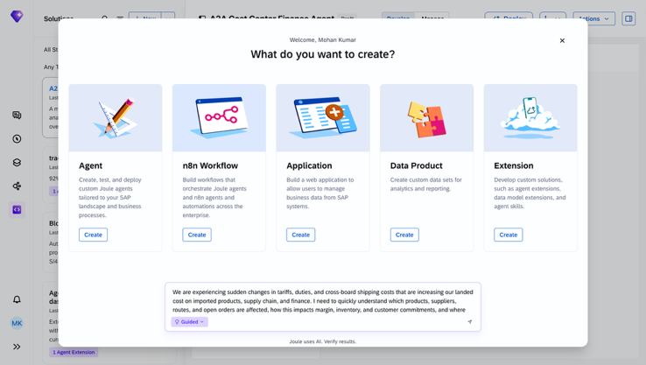
Intent | Everything starts with intent.  You describe what you want to build and the business outcome in plain language.  Joule Studio enriches your intent with business context. It connects to Signavio, LeanIX, and the SAP Knowledge Graph to ground your idea in how the business actually runs.  It surfaces the right APIs and MCP servers, so you are not starting from scratch.  Joule Studio also asks clarifying questions to refine the requirements and logic. | 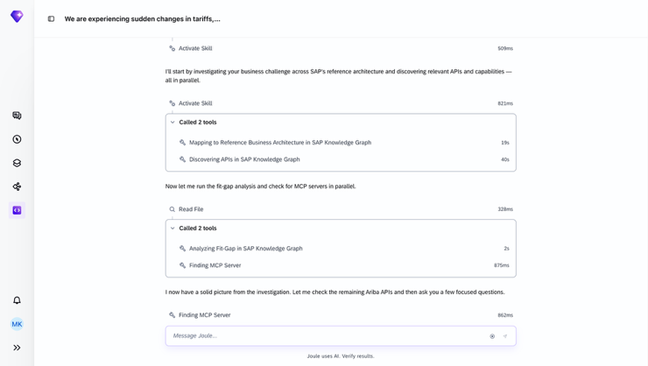
Product Requirements Document | Once the intent is clear, Joule Studio turns it into a product requirements document, or PRD. It is a shared plan that everyone can align on rather than interpret differently.  The document captures the problem, the users, the success measures, and the requirements that actually matter. That way, business and technical teams are looking at the same thing.  And this document stays live. Intent does not disappear once development begins; it remains visible and traceable throughout the process. | 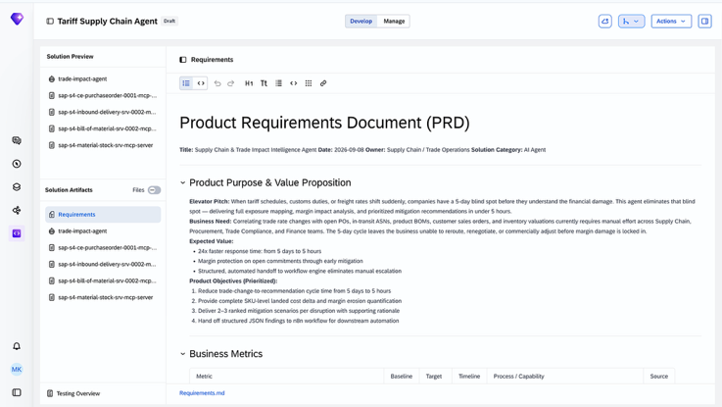
Specification | The PRD tells you what to build. The specification tells you how.  This is where we lock in the scope, architecture, integrations, security, and specific tasks the build agent needs to follow.  This is also where guardrails are added. Compliance and safety are built into the blueprint, not bolted on later.  For developers, that means fewer rework loops and better output quality. | 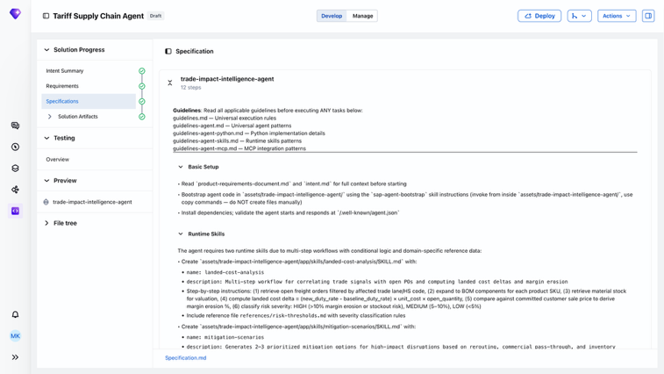
Code Generation | Now Joule Studio does the heavy lifting and turns that blueprint into a solution with working code.  Review and iterate on the code right here in the browser editor.  However, you do not have to adopt a new toolchain just because AI is writing the code.  Joule Studio lets you generate and edit code in the tools developers already use while keeping the same flow and artifacts intact.  Hand off to your preferred development tools, such as VS Code, Claude Code, or Cursor. | 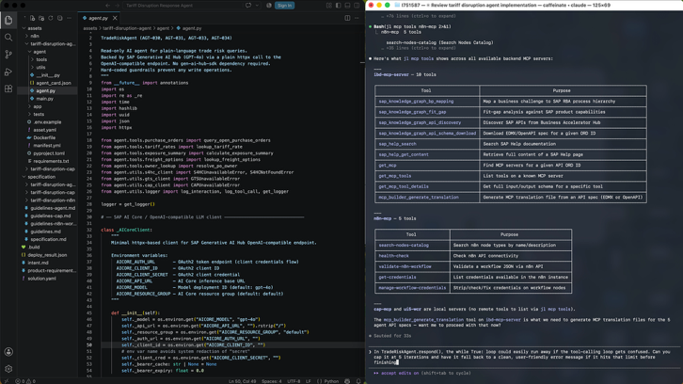
Testing | We have code. Now we need to know whether it behaves as intended. You can preview your agent here.  Joule Studio also runs a test suite to validate the end-to-end flow. For agents, it is not enough to confirm that the code ran; the logic and behavior must also make sense.  Automated evaluations produce a single test report with clear pass-or-fail signals and behavioral checks. | 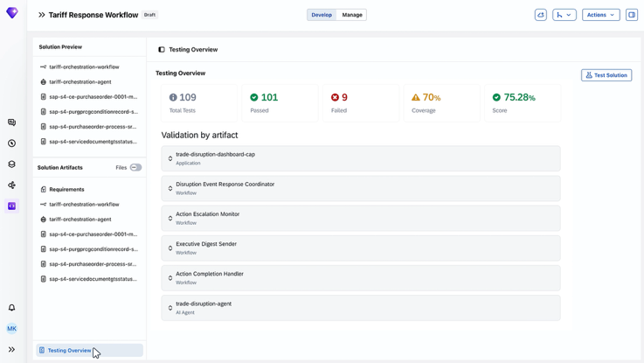
Deployment and Operations | Testing gives you the confidence to ship. This is where the solution becomes real.  The full solution is versioned and pushed to GitHub, making it reviewable, repeatable, and portable across teams.  It then deploys to an SAP-managed runtime. SAP handles scaling, monitoring, security, and compliance, so you can focus on the agent configuration and logic.  And you do not lose visibility once it is running. Performance, cost, and usage are tracked continuously. Tracing, metrics, and logging help you observe behavior, diagnose issues, and keep improving.  AI Agent Hub ties it all together: one place to discover, manage, and govern everything deployed across the lifecycle. | 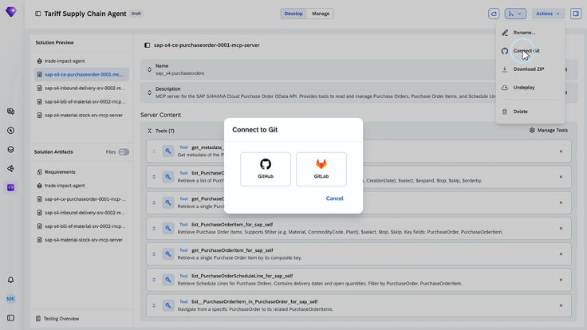
Wrap-up | That is a quick tour of Joule Studio, from intent all the way to production.

